Project Planning Phase
Project Planning Template (Product Backlog, Sprint Planning, Stories, Story points)

Date | 10 September 2026
Team ID | SWUID2026190374
Project Name | ServiceNow-Based Employee Laptop Request Application
Maximum Marks | 5 Marks

Product Backlog, Sprint Schedule, and Estimation (4 Marks)
Use the below template to create the product backlog and sprint schedule for the ServiceNow employee laptop request application.
Sprint | Functional Requirement (Epic) | User Story Number | User Story / Task | Story Points | Priority | Team Members
Sprint-1 | Employee Laptop Request | USN-1 | As an employee, I can open the ServiceNow laptop request catalog item and enter required employee details. | 2 | High | SWUID2026190374
Sprint-1 | Employee Laptop Request | USN-2 | As an employee, I can select an approved laptop type and provide business justification. | 2 | High | SWUID2026190374
Sprint-1 | Approval Workflow | USN-3 | As a manager, I can review the request details and approve or reject the laptop request. | 3 | High | SWUID2026190374
Sprint-1 | Approval Workflow | USN-4 | As the system, I can route the request automatically to the employee’s manager. | 2 | High | SWUID2026190374
Sprint-1 | Request Tracking | USN-5 | As an employee, I can view the submitted request and its current status. | 3 | Medium | SWUID2026190374
Sprint-2 | IT & Asset Validation | USN-6 | As an IT agent, I can validate employee eligibility and existing assigned assets. | 5 | High | SWUID2026190374
Sprint-2 | Fulfillment | USN-7 | As an IT agent, I receive an automatically created fulfillment task for an approved request. | 3 | High | SWUID2026190374
Sprint-2 | Notifications & Closure | USN-8 | As the system, I can notify stakeholders when a request is submitted, approved, rejected or completed. | 2 | Medium | SWUID2026190374
Sprint-2 | Notifications & Closure | USN-9 | As an IT agent, I can update fulfillment progress and close the request with completion details. | 3 | High | SWUID2026190374
Sprint-2 | Reporting | USN-10 | As an administrator, I can monitor laptop requests, states and SLA progress. | 4 | Medium | SWUID2026190374

Project Tracker, Velocity & Burndown Chart: (4 Marks)
Sprint | Total Story Points | Duration | Sprint Start Date | Sprint End Date (Planned) | Story Points Completed (as on Planned End Date) | Sprint Release Date (Actual)
Sprint-1 | 8 | 6 Days | 9 Sep 2026 | 9 Sep 2026 | 8 | 10 Sep 2026
Sprint-2 | 7 | 6 Days | 9 Sep 2026 | 9 Sep 2026 | 7 | 10 Sep 2026
Sprint-3 | 7 | 6 Days | 9 Sep 2026 | 9 Sep 2026 | 7 | 10 Sep 2026
Total | 22 | 18 Days |  |  | 22

Total completed story points = 12 + 17 = 29
Number of completed sprints = 2
Average team velocity = 29 / 2 = 14.5 story points per sprint
Velocity:
For this project, the planned sprint duration is 10 days. The team plans and tracks story points completed within each sprint. Average velocity is calculated as total completed story points divided by the number of completed sprints.
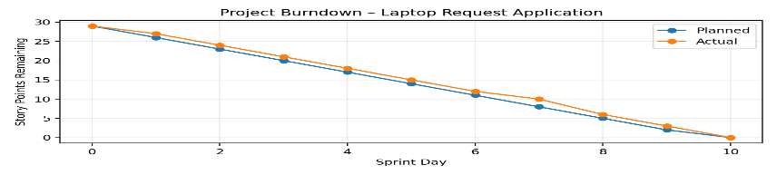

Burndown Chart:
Burndown Chart: The chart below tracks story points remaining across the 10-day sprint plan. The project starts with 29 story points and reaches 0 when all planned stories are completed.

https://www.visual-paradigm.com/scrum/scrum-burndown-chart/
https://www.atlassian.com/agile/tutorials/burndown-charts
Reference: Agile/Scrum planning concepts and ServiceNow project workflow design.
https://www.atlassian.com/agile/project-management
https://www.atlassian.com/agile/tutorials/how-to-do-scrum-with-jira-software
https://www.atlassian.com/agile/tutorials/epics
https://www.atlassian.com/agile/tutorials/sprints
https://www.atlassian.com/agile/project-management/estimation

